**To do list：**

1. Please read the manual of function ‘fspecial’ in the following link,

<https://ww2.mathworks.cn/help/images/ref/fspecial.html>, try different sizes of ‘laplacian’, ‘log’, ’sobel’ and other spatial filters. Figure out the effect of different type and size of spatial filters.

Once you figured out some special function or effect of certain spatial filter, build up a comparison figure like the one below to present the special effect you found.

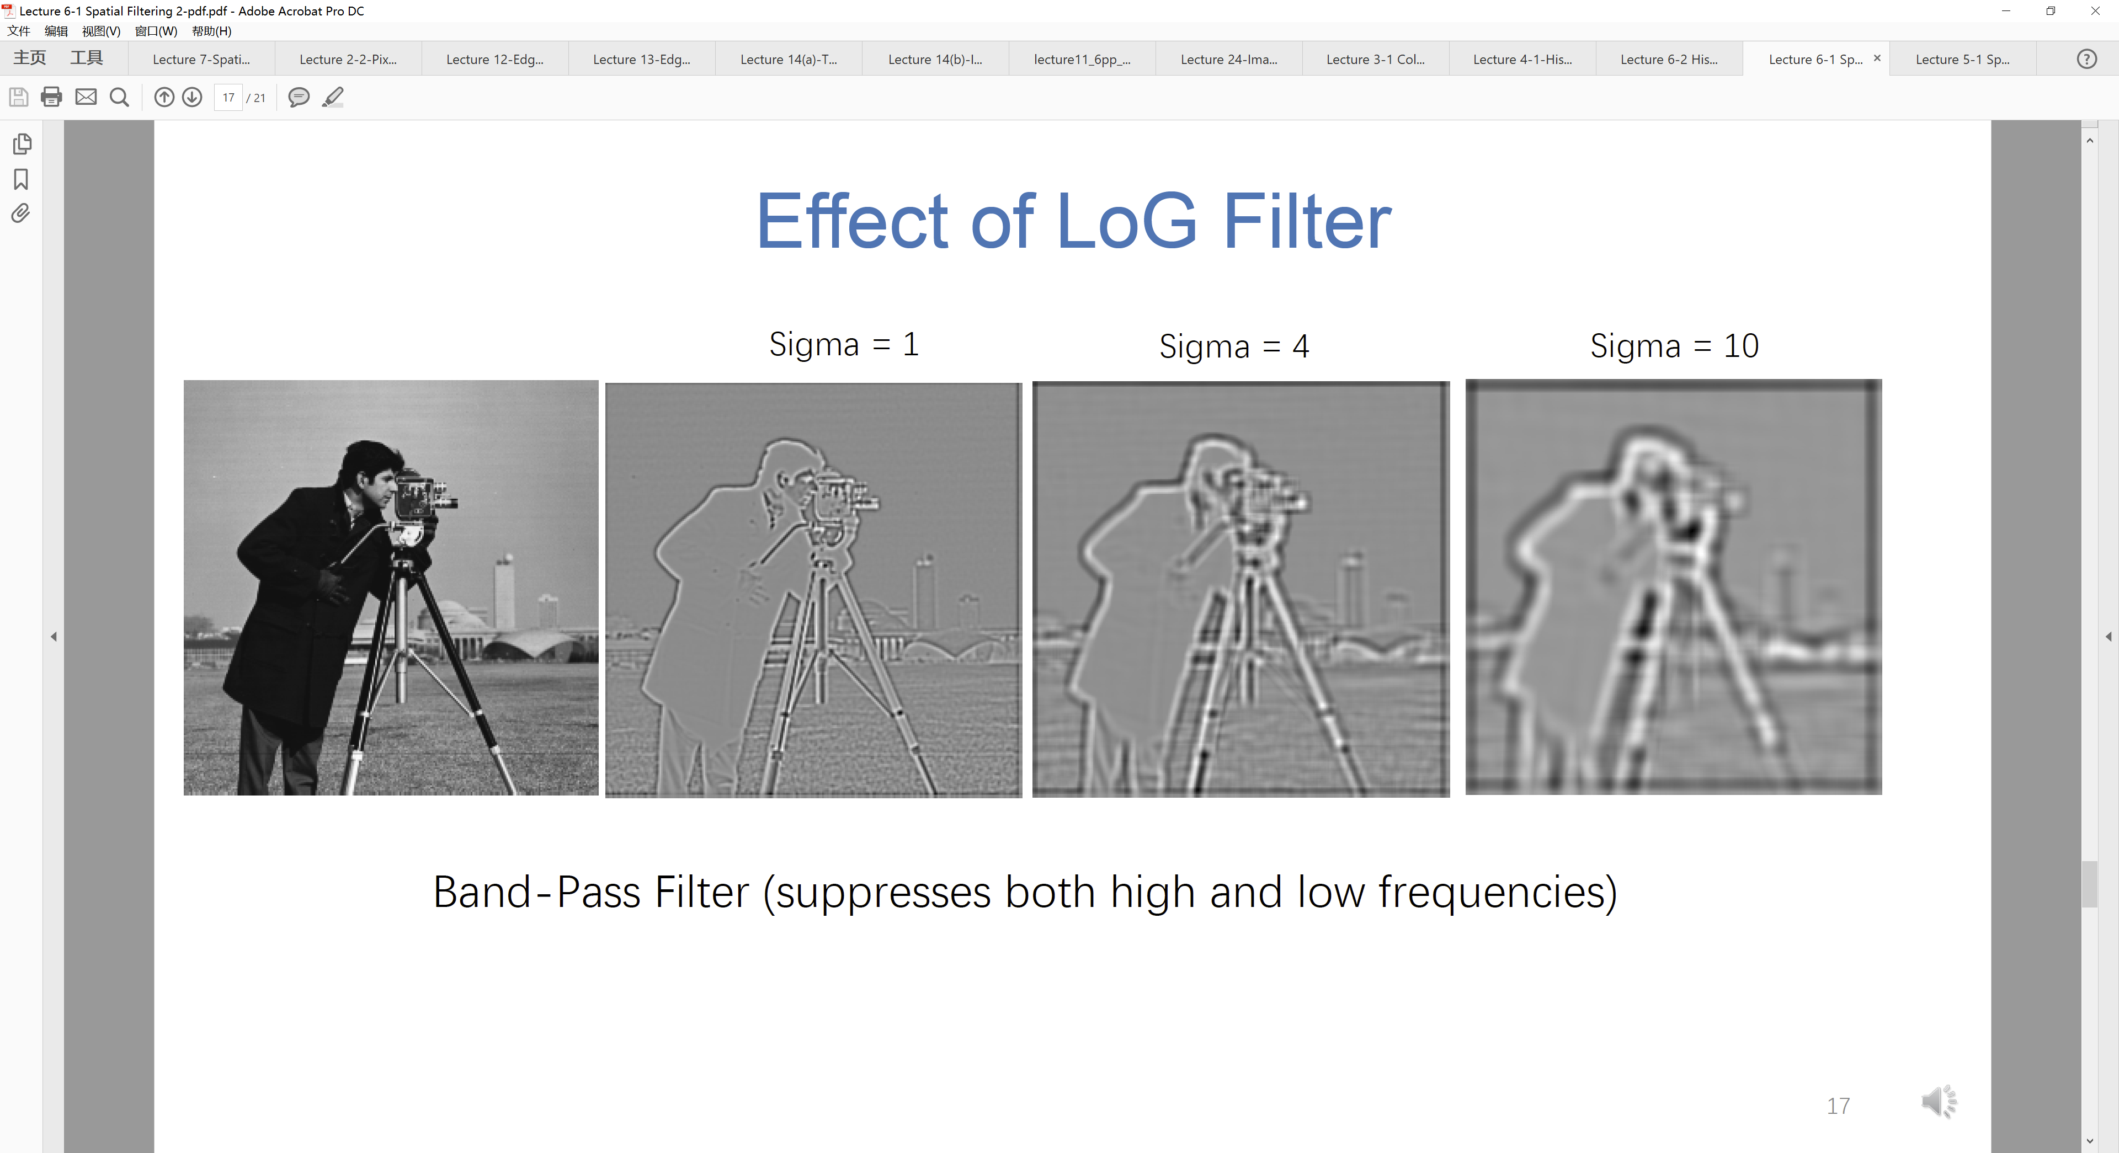

1. Please read the manual of function ‘adapthisteq’ in the following link, <https://ww2.mathworks.cn/help/images/ref/adapthisteq.html>.

Apply both naïve and contrast limit adaptive histogram equalization using function ‘adapthisteq’, play with the size of 𝑊 ∗ 𝑊 patch to see the effect of local neighbor-hood dimension on equalization. Figure out how to find a proper value for clip limit when applying CLAHE.

Find your own image that is able to show the different effect of AHE and CLAHE.